**Operations and HR Strategy Analysis of UnitedHealth Group**

Anushareddy Ramachandra Reddy

**To:** Executive Board, UnitedHealth Group

**From:** Strategy & Analytics Team Member Anushareddy Ramachandra Reddy

**Subject:** Operations and HR Strategy Analysis of UnitedHealth Group

**Introduction**

UnitedHealth Group (UHG) is a topmost healthcare company well known for its integrated services through UnitedHealthcare (insurance) and Optum (health services). The company uses health coverage, clinical services, and data-driven solutions to improve patient care and operational efficiency. This memo reviews UHG’s operations and human resources (HR) strategies, focusing on how they support the company’s long-term goals. It also examines how UHG uses analytics to optimize decision-making in both operations and HR functions. Concepts from Harvard Business Review (HBR) readings on strategy and HR analytics inform this evaluation. Additionally, insights from LinkedIn Learning resources help highlight industry best practices used by UHG.

**1. Operations Strategy**

United Health Group ‘s strategy revolves around several key factors that helps to increase its growth, efficiency, and leadership in the healthcare industry. These factors form the foundation of both its operational and strategic decision-making.

**Integrated Care and Insurance Model:**

UHG uses vertically integrated business strategy, in which Optum provides analytics, pharmaceutical care, and health services while UnitedHealthcare manages insurance, is its operational strength. This integration helps to minimizes inefficiencies and produces a smooth patient experience by giving UHG authority over the funding and provision of healthcare. It puts the business in a position to reduce expenses, better coordination, and improve results throughout the care spectrum.

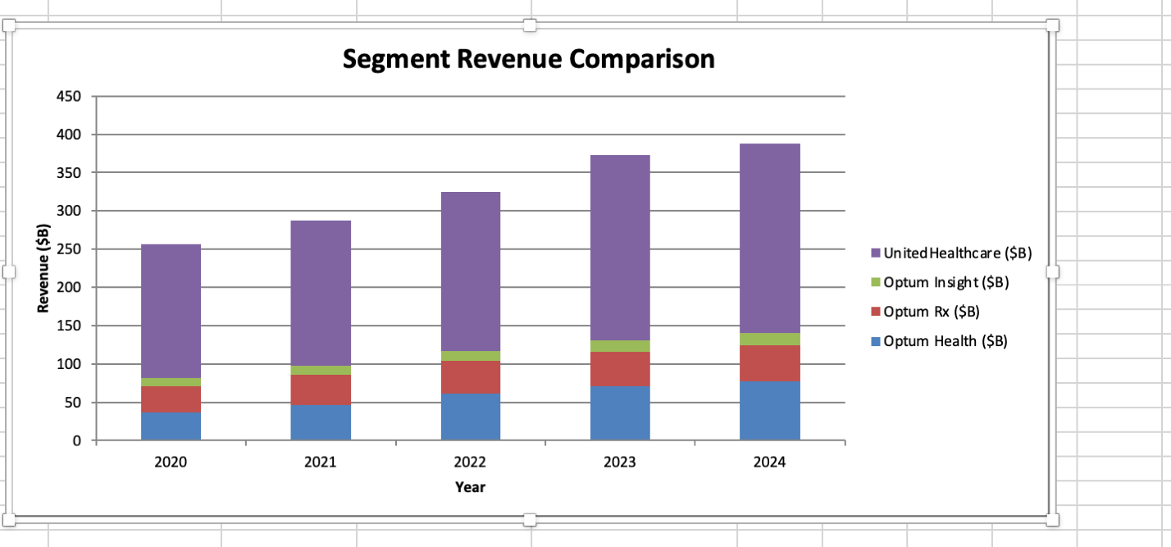

**International Operational Growth:**

By providing regional insurance and care delivery models in more than 140 countries, UHG is expanding its operational strategy internationally. UHG diversifies its sources of income and lessens its excessive reliance on the American healthcare system by customizing services to satisfy regional legal and cultural requirements, particularly in Latin American countries like Brazil and Chile.

**Technology Infrastructure:**

The company invests more in digital platforms, such as mobile health technologies and cloud computing which helps to support the virtual care delivery, member self-service portals, and digital claims processing. These technology-focused operations help to improve scalability, lessen administrative load, and give patients and clinicians a more individualized experience.

**Data-Driven Decision-Making:**

UHG uses artificial intelligence and advanced analytics throughout its operations to track patient care, forecast health outcomes, and optimize internal procedures. To improve treatment plans, lower readmission rates, and support real-time decision-making, it uses data from millions of patient records. Predictive modeling also makes it possible to respond early for high-risk patients, which lowers long-term expenses and emergency visits.

**2. HR Strategy Overview**

**Diversity, Equity, and Inclusion:**

The goal of UnitedHealth Group is to promote an inclusive and diverse workplace. Women make up 70% of the company's global workforce, and 59% of management roles are held by women. The fact that people from a variety of racial and ethnic origins make up 45% of the workforce in the US, with 31% of them holding management positions, is indicative of UHG's continuous efforts to guarantee equity and representation. To increase diversity and boost employee involvement at all organizational levels, UHG has also relaunched Employee Resource Groups (ERGs).

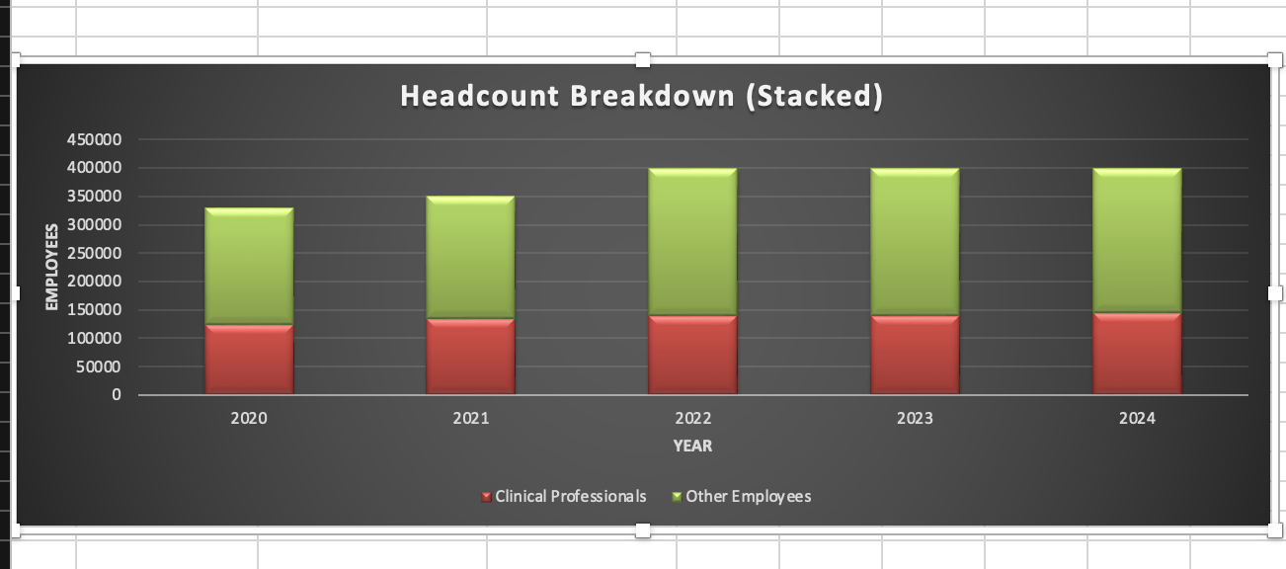

**Performance-Based Compensation and Pay Equity:**

UHG uses a pay-for-performance model, which links executive compensation to the success of the business. Regular pay equity reviews are carried out by the organization to guarantee equitable compensation policies. Women and people of color make $1 for every $1 earned by their peers who do identical jobs at comparable levels, according to a 2023 assessment**.**

**Employee Well-Being and Support:**

Through its "United Well-being" initiative, which emphasizes four pillars—life, financial, emotional, and physical health. UHG places a high priority on the entire well-being of its employees. This program provides resources like work-life balance assistance, financial coaching, fitness activities, and mental health services. For example, Peloton programs, gym memberships, and mental health coaching are available to staff members.

**Governance and Ethical Compliance:**

By using independent compensation experts and executing a restitution provision for executive misconduct or financial restatements, UHG upholds strong standards of corporate governance. Across all its international HR activities, the company also places a strong emphasis on moral conduct and legal compliance.

**Talent Development and Leadership Growth:**

The business funds leadership development initiatives such as "Leadership Edge," which aims to improve senior executives' collective decision-making, strategic thinking, and team-building abilities. As a result of this program, net income increased significantly, proving the value of developing strategic leaders.

**3. Strengths of UHG HR Analytics:**

1. **Advanced Predictive Capabilities:**

UHG uses HR analytics to predict employee turnover and to identify engagement trends, which helps in proactively addressing workforce challenges.

1. **Focus on Clinical Workforce Insights:**

Analytics play a crucial role in optimizing staffing models and compensation for clinical roles, which are very vital in healthcare delivery.

1. **Data-Driven Diversity Initiatives:**

HR analytics also supports UHG's strong commitment to diversity and inclusion, which helps to track down the workforce demographics and informing initiatives to improve representation.

1. **Integration with Business Strategy:**

HR analytics at UHG is often aligned with broader business goals, also enabling leadership to make informed decisions on talent acquisition, retention, and development.

**4. Weaknesses of UHG HR Analytics:**

1. **Regional Disparities:**

Adoption and effectiveness of HR analytics tools may vary by region, showing lower utilization in parts of Asia and Europe.

1. **Career Development Metrics Are Not Very Transparent:**

Survey data also suggests that employees are lack of clarity on how HR analytics helps in promotions and career pathing.

1. **Possible Underutilization of ERG Information:**

While Employee Resource Groups are revitalized, there's limited public insight into how data from these groups’ feeds into broader analytics for inclusion and engagement.

**5. Integration of Analytics in HR:**

UnitedHealth Group (UHG) uses advanced HR analytics across several key functions to enhance workforce management and strategic decision-making.

**Workforce Planning:**

The workforce planning process at UHG includes developing forecasting models that evaluate past data to estimate future employment requirements. In order to compare personnel levels and create supply scenarios, capacity planning models that conduct sensitivity studies must be managed. This kind of predictive modeling helps match the supply of workers with the expected demand. ​

**Attrition Prediction:**

Predictive analytics is used by UHG to identify workers who are about to leave the company. To predict possible attrition, machine learning models analyze historical data, including employee demographics, performance metrics, and engagement surveys. As a result, HR teams may proactively adopt targeted retention tactics.

**Talent Acquisition:**

UHG uses data analytics in the hiring process to improve its talent acquisition tactics. HR can speed up the hiring process, find efficient sourcing channels, and guarantee compatibility with corporate objectives by evaluating recruitment data.

**6. Effectiveness of Strategy Implementation**

Several strategic initiatives have been implemented by UnitedHealth Group (UHG) with the goals of improving patient outcomes, boosting healthcare delivery, and boosting financial performance. Although many of these tactics have been successful, new developments point to places where problems have surfaced.

**Cost Management and Efficiency:**

Independent research conducted by ZS Associates and Wakely Consulting Group has confirmed that UnitedHealthcare, a UHG subsidiary, achieves a total cost of care that is around 10% cheaper than that of other carriers. This is explained by tactics like inpatient management and site-of-care redirection.

**Expansion of Value-Based Care Models:**

With a focus on providing high-quality treatment while keeping costs under control, UHG has taken the lead in the shift to value-based care. UHG subsidiary Optum Health stated that when it came to treating Medicare Advantage patients, their primary care offices fared better than rivals.

**Financial Performance and Growth:**

In 2023, UHG reported robust financial results. They are:

* UnitedHealthcare revenues grew by $31.6 billion, a 12.7% increase year-over-year
* Operating earnings increased by 14.2% to $16.4 billion
* Optum's full-year revenues grew by 24% to $226.6 billion.

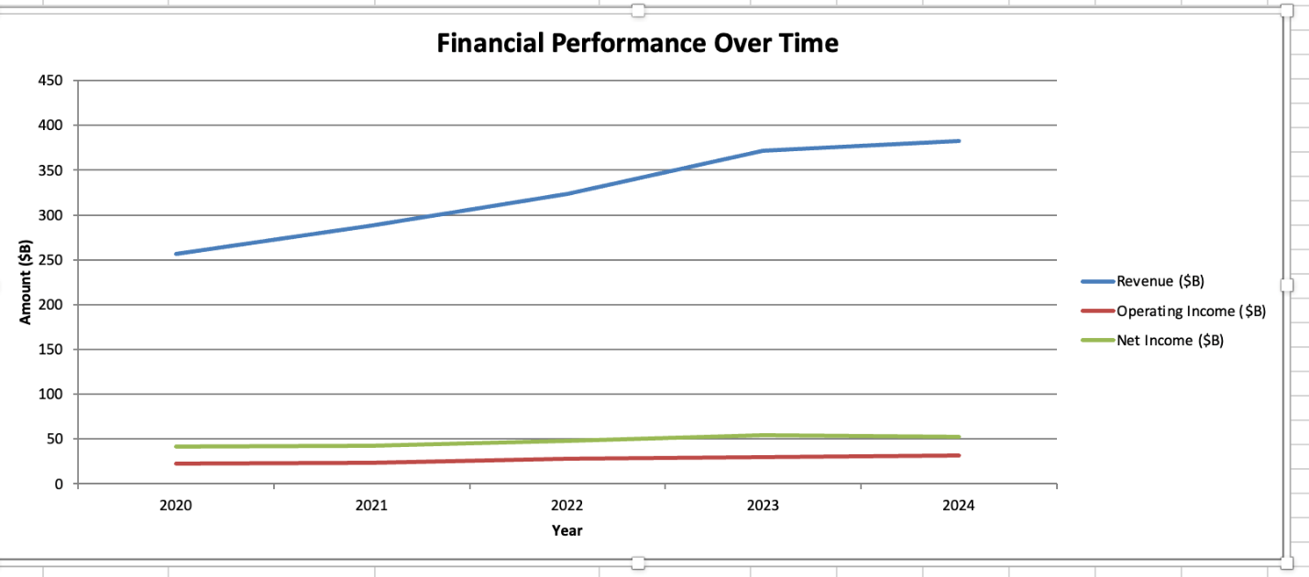

**Technological Integration and Innovation:**

UHG gives clinicians the tools they need to create and apply technology solutions that improve care delivery and operational effectiveness through initiatives like the Clinician Leader Executive program. Initiatives have been started, for example, to improve patient outcomes and responsiveness by instantly notifying clinicians of changes in a patient's status and test findings. ​

**7. Challenges and Recommendations:**

**Public Scrutiny and Regulatory Challenges:**

UHG faces regulatory obstacles, such as inquiries into its diagnostic procedures, and increasing public scrutiny. Reputational harm and maybe legal consequences may result from these problems.

**Recommendations:**

To meet public criticism and regulatory concerns, UHG should increase transparency by disclosing audit findings and corrective actions on a regular basis. Internal compliance programs can be strengthened, and thorough training can be provided to ensure diagnostic and billing requirements are met. Proactive communication with authorities and the public will aid in the restoration of trust while reducing reputational and legal risk.

**Cyberattack on Change Healthcare:**

The data of more than 100 million people was exposed by a ransomware attack that struck UHG's subsidiary, Change Healthcare, in early 2024. The breach caused serious financial losses and operational disruptions; the expected costs for 2024 range from $2.3 billion to $2.45 billion.

**Recommendations:**

To limit the consequences of such cybersecurity breaches, UHG should invest in advanced threat detection technologies and keep its cybersecurity infrastructure up to date. Implementing zero-trust architecture and conducting regular third-party security audits can help to improve data security. Furthermore, providing affected people with transparent communication and identity protection services would assist in rebuilding confidence and limit reputational damage.

**Broader Industry Impact:**

UHG's financial difficulties have spread throughout the health insurance market, affecting investor trust in comparable companies. UHG's results release led to stock decreases for other health insurers such as CVS Health, Humana, Elevance Health, and Centene. ​

**Recommendations:**

UHG needs to offer precise, forward-looking advice supported by data-driven recovery plans to win back investor trust. To reassure stakeholders, financial communication should be strengthened by proactive risk disclosures and transparent earnings calls. Working together on common issues with colleagues in the business could also assist to stabilize market sentiment throughout the health insurance industry.

**Surge in Medicare Advantage Costs:**

UHG saw an unexpected rise in care utilization among Medicare Advantage participants, notably for outpatient and physician care. This spike resulted in greater medical costs, prompting the corporation to reduce its earnings outlook for 2025. On April 17, 2025, the company's shares fell by over 22%, the worst single-day performance in over 25 years. ​

**Recommendations:**

UHG should improve predictive analytics to better estimate healthcare demand and modify care models in response to increased care utilization. Value-based provider partnerships and the growth of preventive care programs can help reduce costs while enhancing results. Stabilizing market responses can also be achieved through open and honest communication with investors regarding long-term cost management plans.

**8. Conclusion:**

UnitedHealth Group's human resources and operations programs complement its goal of providing premium, reasonably priced healthcare. The company's global expansion, data analytics, and integrated care approach have improved patient outcomes and efficiency. Even in the face of recent difficulties including increased Medicare Advantage costs, cybersecurity breaches, and regulatory scrutiny, resilience and adaptability are crucial for ongoing success. By emphasizing cybersecurity, transparency, compliance, and predictive technologies, UHG may improve its standing. A stable organization will be able to navigate the changing healthcare landscape with the support of effective stakeholder communication.

**References:**

* **UnitedHealth Group. (2023).** UnitedHealth Group Reports 2023 Results. Retrieved from <https://www.unitedhealthgroup.com/content/dam/UHG/PDF/investors/2023/UNH-Q4-2023-Release.pdf>
* **UnitedHealth Group. (2024).** *Annual Report 2023*. Retrieved from:  
  <https://www.unitedhealthgroup.com/content/dam/UHG/PDF/investors/2024/UNH-Q4-2024-Form-10-K.pdf>
* **UnitedHealth Group.** (n.d.). UnitedHealth Group. Retrieved from <https://www.unitedhealthgroup.com/>
* **UnitedHealth Group Financial Statements (2015-2024).** Macro Trends. Retrieved from <https://macrotrends.net/stocks/charts/UNH/unitedhealth-group/financial-statements#google_vignette>
* **UnitedHealth Group.** Fourth-quarter 2023 results and full-year financial highlights. Retrieved from <https://www.unitedhealthgroup.com/newsroom/2024/2024-01-12-uhg-reports-fourth-quarter-results.html>
* **UnitedHealth Group.** Fourth-quarter 2023 earnings report submitted to the SEC. Retrieved from <https://www.sec.gov/Archives/edgar/data/731766/000073176624000023/a2023q4exhibit991.htm>
* **Managed Healthcare Executive.** UnitedHealth Group’s 2023 revenue growth and performance overview. Retrieved from <https://www.managedhealthcareexecutive.com/view/unitedhealth-group-s-revenue-grew-almost-15-in-2023>